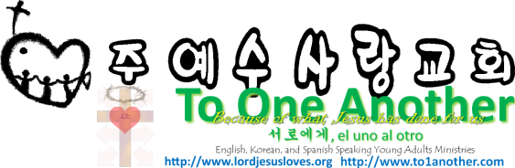
What is the Gospel?
Pastor Yoo Nam Kang
John 3:16
June 17, 2012

John 3:16
“For God loved the world so much that he gave his one and only Son, so that everyone who believes in him will not perish but have eternal life.
Hebrews 7:28
The law appointed high priests who were limited by human weakness. But after the law was given, God appointed his Son with an oath, and his Son has been made the perfect High Priest forever.
Ephesians 1:13
And now you Gentiles have also heard the truth, the Good News that God saves you. And when you believed in Christ, he identified you as his own by giving you the Holy Spirit, whom he promised long ago.
2Corinthians 4:15
All of this is for your benefit. And as God’s grace reaches more and more people, there will be great thanksgiving, and God will receive more and more glory.

- Gospel is Jesus Himself
Romans 1:1, 4
1 This letter is from Paul, a slave of Christ Jesus, chosen by God to be an apostle and sent out to preach his Good News. 4 and he was shown to be the Son of God when he was raised from the dead by the power of the Holy Spirit. He is Jesus Christ our Lord.

- Gospel is Living Heavenly Life
John 14:10, 12
10 Don’t you believe that I am in the Father and the Father is in me? The words I speak are not my own, but my Father who lives in me does his work through me. 12 “I tell you the truth, anyone who believes in me will do the same works I have done, and even greater works, because I am going to be with the Father.
John 8:28
So Jesus said, “When you have lifted up the Son of Man on the cross, then you will understand that I Am he. I do nothing on my own but say only what the Father taught me.
John 12:50
And I know his commands lead to eternal life; so I say whatever the Father tells me to say.”
John 14:24
Anyone who doesn’t love me will not obey me. And remember, my words are not my own. What I am telling you is from the Father who sent me.

- Gospel is the New Covenant
Hebrews 10:9
Then he said, “Look, I have come to do your will.” He cancels the first covenant in order to put the second into effect.
Ezekiel 36:26-27
26 And I will give you a new heart, and I will put a new spirit in you. I will take out your stony, stubborn heart and give you a tender, responsive heart. 27 And I will put my Spirit in you so that you will follow my decrees and be careful to obey my regulations.
Matthew 7:13
“You can enter God’s Kingdom only through the narrow gate. The highway to hell is broad, and its gate is wide for the many who choose that way.
John 10:7, 9
7 so he explained it to them: “I tell you the truth, I am the gate for the sheep. 9 Yes, I am the gate. Those who come in through me will be saved. They will come and go freely and will find good pastures.
Matthew 7:7, 11
7 “Keep on asking, and you will receive what you ask for. Keep on seeking, and you will find. Keep on knocking, and the door will be opened to you. 11 So if you sinful people know how to give good gifts to your children, how much more will your heavenly Father give good gifts to those who ask him.
Luke 11:13
So if you sinful people know how to give good gifts to your children, how much more will your heavenly Father give the Holy Spirit to those who ask him.”
Matthew 10:20
For it is not you who will be speaking—it will be the Spirit of your Father speaking through you.
Mark 13:11
But when you are arrested and stand trial, don’t worry in advance about what to say. Just say what God tells you at that time, for it is not you who will be speaking, but the Holy Spirit.
Hebrews 3:19
So we see that because of their unbelief they were not able to enter his rest.

